Avoiding Online Dangers
What is the danger shown by this image?

List as many ways as you can think to avoid this danger:

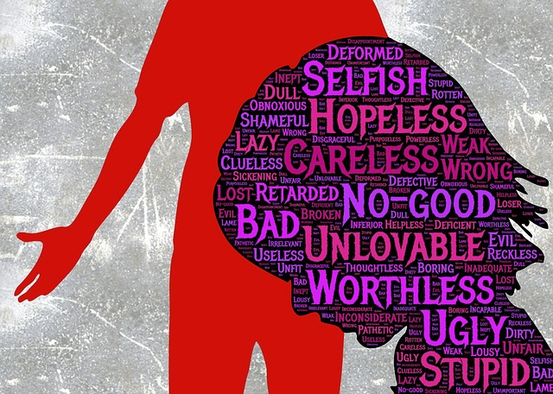

What is the danger shown by this image?

List as many ways as you can think to avoid this danger:




What is the danger shown by this image?

List as many ways as you can think to avoid this danger:


What is the danger shown by this image?

List as many ways as you can think to avoid this danger:


What is the danger shown by this image?

List as many ways as you can think to avoid this danger:

